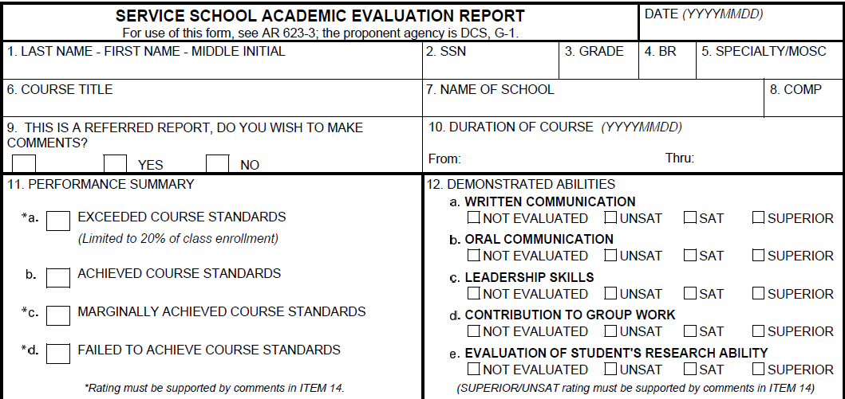
Smith, Jimmie, D
555-55-5555
E5
?
68W30
Write it here
Write it here
??
Date
Date
X
X
X
X
X
X
X
20101023
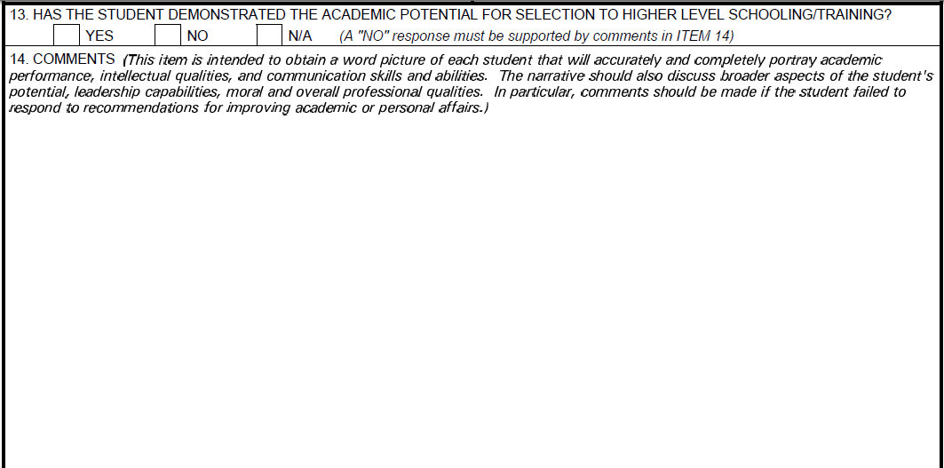
X
NOTES:
FOR BLOCKS 9, 11, 12, 13 YOU MUST CLICK ON THE TEXT BOX AND THEN YOU CAN MOVE IT WITH YOUR ARROWS UP, DOWN, LEFT AND RIGHT TO PLACE THE x IN THE DESIRED BOX
THANK YOU FOR VISITING
NCOSUPPORT.COM
YOU CAN NOW DELETE THIS NOTE AND WRITE IN YOUR COMMENTS
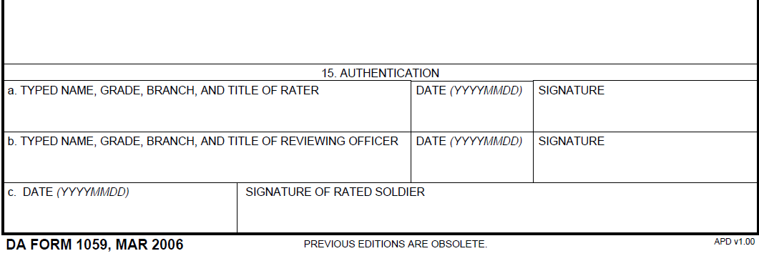
JOHN D. SMITH, E6, FA, TITLE
20100923
JOHN B. SMITH, O4, FA, TITLE
20100923
20100923

